  - The Logic and Outcomes of U.S. Empire
Samuel Finesurrey and Gary Greaves

Introduction

How did the United States become the most powerful country in the world? How has the justification for U.S. intervention overseas changed overtime? What does it take to become a U.S. ally? Why does the United States fight wars around the world? How have the motivations for U.S. actions abroad evolved? How have they remained the same? What is the relationship between U.S. empire and immigration to the United States?

Throughout its history the United States has undergone multiple phases of foreign policy, yet patterns have emerged as to when and why the U.S. engages overseas. The United States, historically and presently, works to protect its economic, cultural and political interests around the world, while often proving hesitant in alleviating the refugee crises that emerge due to U.S. actions abroad.

Manifest Destiny

The United States has historically worked to justify its foreign policy, to frame itself as the “good guy” in a righteous battle between good and evil. The first manifestation of this logic was eventually titled “Manifest Destiny.”

Manifest Destiny explained U.S. expansion westward, by claiming that the seizing of Native and Mexican territory was legitimate because God willed it. In the 1600s Reverend Cotton Mather of Massachusetts explained, “Warfare against the Indians was a conflict between the devil and God.” On the side of God were the Anglo-American colonists who saw their military superiority, and the death of Native Americans due to disease as divine proof that they, not the natives, were chosen to inhabit the land. John Winthrop who led settlers to 17th century Massachusetts explained that, “God was making room for the settlers and hath hereby cleared our title to this place.” (Takaki) According to Anglo-Americans, God wanted the Natives gone. To these white colonizers, divine providence justified a war of extermination against native peoples to clear more of the American landmass for Christians whose families came from Europe.

From the founding of the United States well into the 20th century, many white U.S. citizens continued to believe that providence had preserved the land of “Others” for them. By the middle of the 19th century, this belief that a divine power had guaranteed all of the land between the Atlantic and Pacific Oceans for the United States developed into a deeply entrenched ideology, a story that white Americans told themselves about themselves. In 1845, this ideology was coined by a journalist as Manifest Destiny.

While continuing to move West and pushing the Natives off their land, White U.S. nationals in the 1830s and 1840s also began to see Mexico as a threat to their ambition to extend U.S. borders.

At the start of the 19th century, undocumented U.S. immigrants flooded into the Mexican province of “Tejas.” Many of these white U.S. settlers owned slaves and were encouraging other Anglo-Americas to join this community of U.S. citizens in the Mexican province. However, slavery was outlawed in Mexico in 1829, leading to tensions between the settlers and the Mexican authorities due to the continued immigration of slave owning families. Largely to preserve the enslavement of people in Tejas, Mexico’s white U.S. immigrants started a war for independence (1835-1836). U.S. nationals from across the United States rushed to join the fight against the Mexican army.

The independent nation of “Texas” emerged from this conflict, yet ascending President James K. Polk embraced an opportunity to acquire the rich ports of Mexico’s California province. After creating conditions to justify an invasion, President Polk sent the troops in. A barbaric war was waged by U.S. forces where atrocities committed against Mexican civilians were widespread. The brutal behavior of the U.S. military led many immigrant Irish troops, fighting with the United States, to switch sides in the conflict and fight with their fellow Catholics in Mexico’s army.

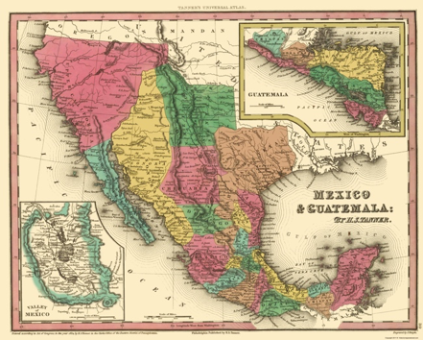
Mexico Before Texas Revolution (1835)
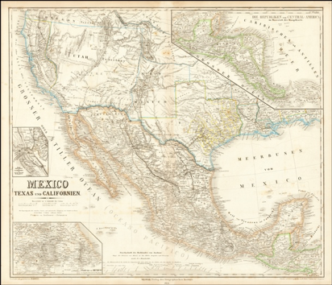
Mexico After Treaty of Guadalupe-Hidalgo
After the Mexican American War (1846-1848), the United States, for the first time on a large scale, militarily expanded its territory through a war with another country. The Mexican American War was formally concluded by the Treaty of Guadalupe-Hidalgo. The treaty granted the United States the disputed Texas territory, as well as land in several future states out West including California. In these territories lived 75,000-100,000 now Mexican Americans. Despite being declared U.S. citizens, for over a century, white U.S. citizens curbed the political, social and economic rights of Mexican Americans throughout the Southwest. The 150,000 Native Americans who lived in these new U.S. territories were slaughtered and brutalized. Within 12 years, the Native population of the area was reduced to 30,000 due to disease, expulsion and genocide.

An Overseas Empire

The term Manifest Destiny disappeared in the years after the Mexican American War, however, it was re-popularized in the 1890s by U.S. citizens looking to expand U.S. influence overseas.

By the 1890s, powerbrokers within the United States were searching for a justification for their occupation and colonization of the Caribbean and Pacific Islands. By the end of the 1800s American logic emphasized that the mission to secure U.S. control of new lands was the selfless desire to “modernize” non-white populations so they too could be “civilized.” The White Man’s Burden is a term deriving from an imperialist poem by Rudyard Kipling, representing a paternalistic idea that to lift up and “civilize” people in Asia, Africa and Latin America, Europeans and white U.S. citizens would need to take control of those places. With this logic to justify U.S. imperialism, Hawaii was annexed by the United States in 1896. The United States wrested the Philippians, Puerto Rico, Guam, and Cuba from Spain in the Spanish American War in 1898. Haiti, the Dominican Republic, Nicaragua, Panama and Vera Cruz, Mexico were all occupied in the first decades of the 20th century. Like today, these interventions overseas upset many U.S. citizens, however, their objections were largely ignored as U.S. businesses prospered while the U.S. government increased its influence in global affairs.

Justification for the War of 1898 or the Spanish American War was secured by circulating propaganda about the evils of Spain’s occupation of Cuba. Before the U.S. intervention in 1898, U.S. political cartoons depicted Cuba as a woman, generally a white woman, in need of rescuing. This trope of “the woman in need of being rescued” will become part of the psychology and mythology of America. The United States quickly defeated Spain with support from Cuban forces who had been waging a revolution off and on over the previous 30 years. In the [ensuing] peace treaty the United States secured Cuba, Puerto Rico, the Philippians, and Guam from Spain. (Pérez, Cuba in the American Imagination)

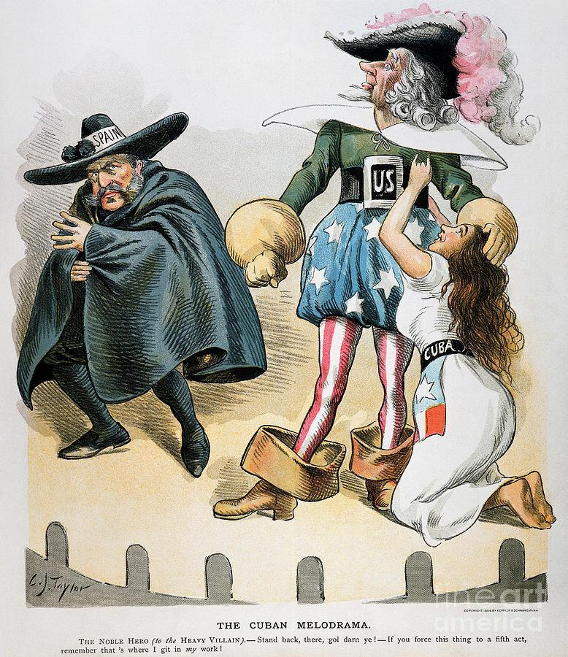

After the United States won the Spanish-American War, the image of Cuba, Puerto Rico, and the Philippians changed in the U.S. Press. In political cartoons Cubans, Puerto Ricans and Filipinos were now displayed as “children,” often Black children as were the Dominicans and Haitian during their periods of U.S. Occupation. This was a fate also suffered by other nations that the United States considered under its sphere of influence. By portraying these peoples as kids, the U.S. press was justifying U.S. control.

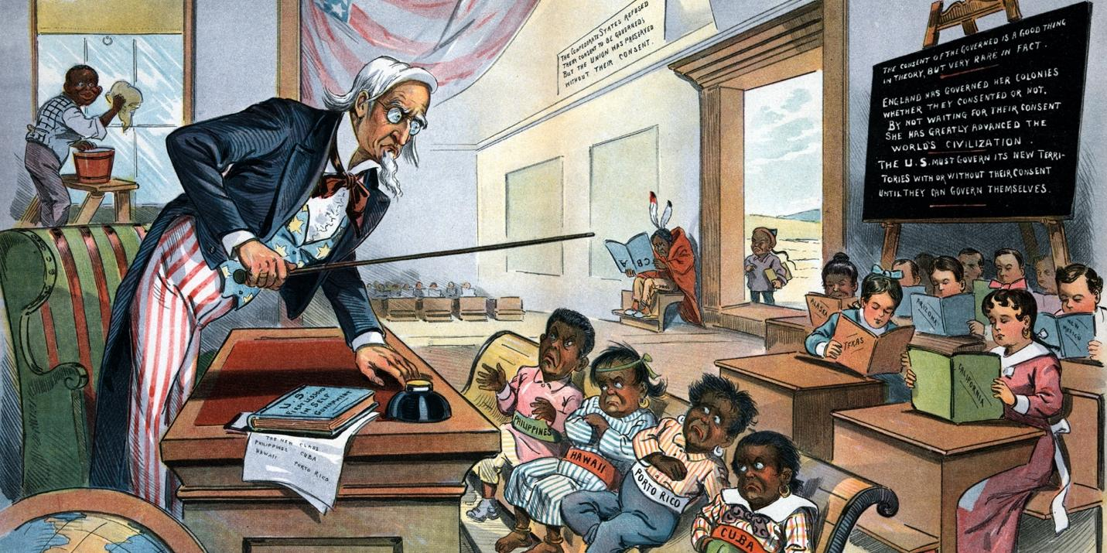
Imagine that you open your local paper in 1900 and see this political cartoon. How do images like this cartoon work to justify the U.S. occupation of Cuba, Puerto Rico, Hawaii and the Philippines?

The occupations and newfound influence of the United States throughout the world proved profitable for U.S. businesses. U.S. companies were able exploit their connections with U.S. officials, often dictating policy in U.S. occupied lands. From the Caribbean to the Pacific, U.S. dollars secured contracts to build national railroads or cultivate farmland. Corporations like the United Fruit Company and National City Bank of New York held enormous sway over U.S. decision making in these occupied territories.

The U.S. government also directly benefited from these new territories as they acquired new military bases, laborers and soldiers without having to provide these peoples with equal rights. For instance, Puerto Ricans were made citizens of the United States in 1917 with the passage of the Jones Act, which made them eligible to be drafted into the U.S. Army during World War One. However, despite widespread service in the armed forces, those citizens who live in Puerto Rico, Guam, the U.S. Virgin Islands, and the Northern Mariana Islands—territories still held by the United States today—were and still are systematically denied voting representation in Congress and are excluded from participating in U.S. Presidential Elections. (John Oliver, “Puerto Rico”) Without the vote, these U.S. territories often experience disadvantageous economic policies and inadequate responses from the Federal Government to natural disasters as when Hurricane Maria struck Puerto Rico in 2017. In 2018 Puerto Rico’s poverty rate stood at 43%. (Hurricane Maria) Overtime, this has led to mass migration of these communities to the United States.

Puerto Rico and the U.S. Government

An “Informal” Empire

By the twentieth century, the U.S. government and its corporations often sought to extract resources without the formal colonization of foreign peoples. The United States was no longer primarily motivated by land acquisition, as had been the case in the conflicts against Native Americans, Mexicans, Hawaiians, and Spaniards. U.S. powerbrokers remained dependent on the backing of the U.S. military in enforcing U.S. empire; however, most U.S. occupations that began after 1900 were temporary.

Still, a return to local rule did not mean a return to national sovereignty. The United States ensured that formerly occupied territories, even upon the exit of U.S. troops, would remain profitable for, and beholden to U.S. businesses. In Cuba, before the United States left the island in 1902, Cubans were forced to insert the Platt Amendment into their constitution specifying that the United States could intervene in the internal affairs of the island. While forcing this Amendment into the Cuban constitution horrified the Cuban population, the United States would not shy away from asserting its right to intervene in Cuban affairs. (Finesurrey, 2018) Platt forced Cuban policymakers to prioritize U.S. economic, political and cultural interests, while severely constraining the effectiveness of Cuban strategies to address Cuban poverty, health care, infrastructure and education. This reality both encouraged immigration from Cuba and led to a revolutionary context that triumphed in ousting the U.S. backed Batista government in 1959. (Finesurrey, 2020)

Economic Interests
Historically, the United States has intervened in sovereign nations culturally, diplomatically, covertly and militarily on behalf of U.S. businesses. U.S. corporations often influence U.S. foreign policy, with U.S. business leaders guiding the President’s actions. U.S. Presidents have depended on private businesses to arm U.S. troops and advise them on regions where they have investments.
Large corporations upset that they were losing profits contacted officials in the administration of President Dwight D. Eisenhower to overthrow the progressive governments of Iran and Guatemala that were demanding more control over their own nations’ resources. U.S. corporations, the CIA and U.S. government officials pushed the U.S. media to cover these coups in a way that justified U.S. intervention. By and large, the media complied. President Jacobo Árbenz of Guatemala and Prime Minister Muhammed Mosaddegh of Iran, both intent on reclaiming their nation’s economic sovereignty, were replaced with dictators who made it their priority to protect U.S. financial interests, generally at the expense of their nation’s poor.

A U.S. Backed Coup in Guatemala
The CIA overthrew Guatemala’s democratically elected Jacobo Árbenz in 1954, because he attempted to exert economic sovereignty for Guatemalans at the U.S.-owned United Fruit Company’s (UFC) expense. The context for Árbenz’ efforts was that United Fruit was able to gain control over 42% of all land in Guatemala, growing bananas for U.S. consumers. (Background on the Guatemalan Coup of 1954) Before the Presidency of Árbenz, the Guatemalan government had made a deal with United Fruit assuring that the wages of Guatemalan peasants would never rise above 50 cents a day and that the company would be exempt from international taxes. (Schlesinger) Guatemalans demanded change.
Jacobo Árbenz won election in 1950 running on a promise to take control of Guatemala from the United Fruit Company. (Kwitny) Árbenz demanded United Fruit accept the Guatemalan government as the final arbitrator in disputes between Guatemalan banana pickers and the company. Árbenz called for a reduction in the rail fees, among the world’s highest due UFC’s monopoly on travel. He insisted that United Fruit begin paying export taxes. Árbenz’ Agrarian Reform Law declared 209,842 acres of unfarmed land owned by United Fruit to be given to peasant Guatemalan families. (Background on the Guatemalan Coup of 1954)
These changes angered UFC executives. United Fruit, however, was confident in its ability to alter the direction of the Guatemalan government. Many people in the Eisenhower administration had deep connections to UFC. The Dulles Brothers, serving as Director of Central Intelligence and Secretary of State respectively, both had worked at the Sullivan and Cromwell law firm. This firm represented United Fruit. (Turner) Eisenhower’s Undersecretary of State Walter Bedell Smith expected to become the President of the United Fruit Company for his political support. (Kwitny) If this was not enough to guarantee backing from Washington, the United Fruit Company had loyally donated their fleet to the U.S. war effort during World War II aiding the commander of Allied forces General—and then President—Dwight D. Eisenhower. (Richter) Collectively, these men decided to support the United Fruit Company and overthrow the Guatemalan government.
The truth would have little impact on the CIA’s campaign to undermine Árbenz. On May Day 1954, due to the unusually large number of workers that would be home, la Voz de Liberación, played its first broadcast. The radio station aired propaganda against the government calling on the people of Guatemala to rise up against Árbenz. They claimed to be broadcasting from the jungles of Guatemala. la Voz de Liberación was developed by the CIA; early broadcasts emanated from Miami and their tapes were beamed into Guatemala with a mobile transmitter. The CIA also worked closely with Catholic priests in Guatemala, pushing them to give anti-Árbenz sermons. (Immerman) With the CIA operation set to begin on June 15, 1954 the U.S. government succeeded in gaining control of the U.S. press reporting from Guatemala. Just before the operation against Árbenz began, the Ambassador met with reporters to chat about “the type of stories they were writing.” The aim was to have this coup covered as a popular uprising, rather than an assault by the United States on Guatemalan democracy. (Cullather)
The U.S.-backed Castillo Armas emerged with a small force of just 480 men. President Eisenhower supplied air support. (Eisenhower) Meanwhile, la Voz de Liberación radio station distorted the successes of Armas’ forces. The CIA blocked all other radio signals. La Voz de Liberación reported mass desertion from Árbenz’ army, which was untrue. Still, unaware of the actual situation, President Árbenz resigned. Armas was elected president in October with a fabricated 99% of the vote after outlawing political parties and screening all potential opponents. President Eisenhower congratulated Armas. (Cullather, Immerman)
Two-hundred-thousand Guatemalans would be killed in a 36-year Civil War caused by the U.S. coup of 1954. The UN concluded in 1999 that the Guatemalan Security Forces, who in large part were trained, funded and given supplies by the United States for the duration of the conflict, committed 93% of the human rights violations during the war. The conflict produced one million refugees. (“Timeline Guatemala”) Today Guatemalans, like Salvadorians and Hondurans, suffer from substantial economic, physical, political and environmental insecurity. The destabilizing influence of U.S. foreign policy decisions in these countries has helped to cultivate the current refugee crisis being played out at the U.S. border and in detainment camps holding Central Americans seeking asylum.

The War on Terror
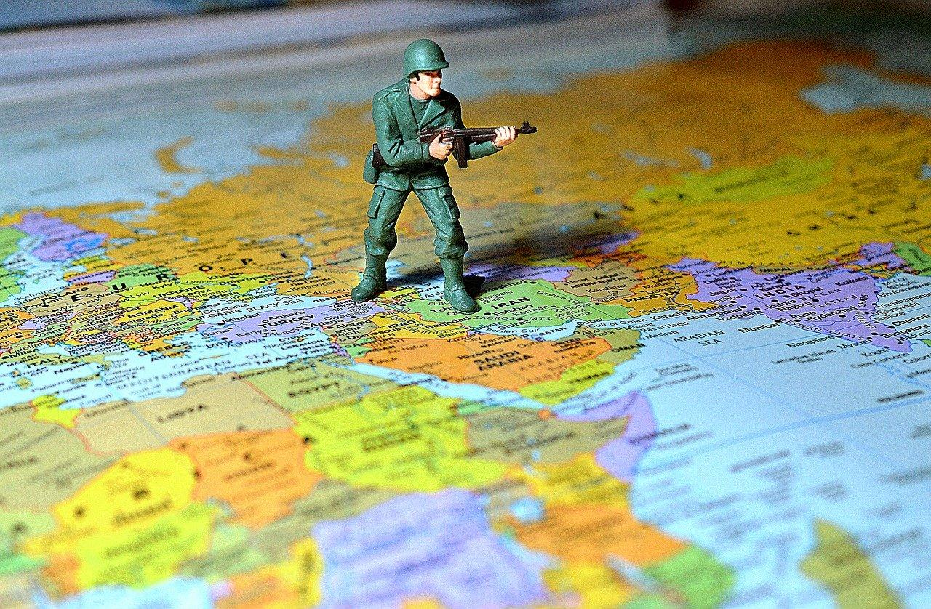

On September 11, 2001 Al Qaeda terrorists armed with simple box cutters took over four passenger planes, transforming them into lethal weapons. They flew two of the jets into the Twin Towers of the World Trade Center in New York City, killing 2,823 people and injuring many others. They flew the third plane into the Pentagon, causing more casualties and serious damage to the building. Passengers prevented the terrorists from flying the fourth plane to Washington, D.C., and that plane crashed in the Pennsylvania countryside. Shown throughout the world, the horrifying shots of the planes flying into the Twin Towers are enduring images of a spectacular attack on the symbols of U.S. economic might. They graphically exposed the ability of terrorists from abroad to attack on U.S. soil. They shocked American politicians, media members and civilians into a patriotic furor that would lead to the longest conflict in U.S. history and a “War on Terror” that continues to this day.

Interview With Osama Bin Ladin

Osama Bin Ladin, who planned the 9/11 attacks, explained that he saw the United States as an imperialist nation that held too much power in the Arabian Peninsula in pursuit of Saudi Arabian oil. As a Saudi himself, Bin Ladin classified U.S. influence in his home nation as an insult to Arab sovereignty and the Muslim faith. Further, Bin Ladin blamed U.S. support of Israel for the death of countless Palestinians. In response, Bin Ladin organized the 9/11 attacks that he hoped would strike at the heart of U.S. economic, military and political power.

In the months after the attacks, as the nation healed, President George W. Bush saw his approval rise to 73%. Scared of another attack, U.S. citizens rallied behind President Bush who promised to keep Americans safe. By 2002 President Bush felt secure enough to advance his doctrine of preemptive war, where the use of force is justified if an imminent threat is perceived. The President and his team spoke pointedly about the “Weapons of Mass Destruction,” being constructed in Iraq that threatened U.S. and global security. (Kellner)

Stories challenging the Bush Administration’s case for war were downplayed. Journalist James Risen wrote extensively about the falsehoods told by the Bush Administration in the lead up to the War in Iraq, only to be censored by his employer, The New York Times. Risen’s article “C.I.A. Aides Feel Pressure in Preparing Iraqi Reports,” documented persuasively that intelligence memos were being altered due to political concerns. The article was completed several days prior to the invasion, but not printed until three days after the start of the war, and relegated to page B10 (Okrent). The Times coverage gave credibility to the administration’s arguments to go to war. Moreover, as the paper of record, many news organizations including CNN and National Public Radio, followed the Times’ lead and the drumbeat to war effort. (American Government and Politics in the Information Age)

The lack of vigorous challenges by leaders of the Democratic Party to the Bush administration in the run-up to the war left little pressure on the news media to investigate the claims of the Bush administration. While many in congress, including Bernie Sanders, Nancy Pelosi, and Barbara Lee voted against the conflict, much of the Democratic leadership including Joe Biden, Hillary Clinton and Chuck Schumer sided with the Republican Bush Administration to authorize the use of force in Iraq. (Vote Count)

As the war began, much of the mainstream media reproduced the U.S. government’s, and the U.S. military’s priorities to frame their coverage of the conflict. Prominent news stories provided by the Bush administration became highly publicized before turning out to be factually inaccurate. The famous rescue of Private Jessica Lynch and the death of Corporal Pat Tillman are most notable among these. Other news stories were manipulated to support the U.S. imperialist perspectives. For instance, the pulling down of Saddam Hussain’s statue was reported as a popular uprising culminating in the destruction of a hated tyrant’s statue. In fact, the statue was removed by a small group of Iraqis alongside journalists and U.S. Marines. When troubling accounts of torture and abuse by U.S. troops, including at Abu Ghraib prison began to emerge, the media turned its attention to tales of U.S. military heroism and images that supported the narrative that the United States was a force for good in Iraq.

Cost of War

The War on Terror has left thousands of U.S. soldiers in the Middle East dead and tens of thousands dealing with injuries and Post-Traumatic Stress Disorder (PTSD). An estimated one million Middle Eastern civilians have been killed directly or indirectly by the turmoil since the United States destabilized the Middle East by overthrowing the governments of Afghanistan and Iraq. As of September 2020, least 37 million refugees have fled their homes due the instability sparked by the War on Terror. (Ismay) Most have sought refugee status in North America, Europe and Australia. The United States government has agreed to take an extremely small percentage of Middle Eastern refugees. (World Economic Forum)

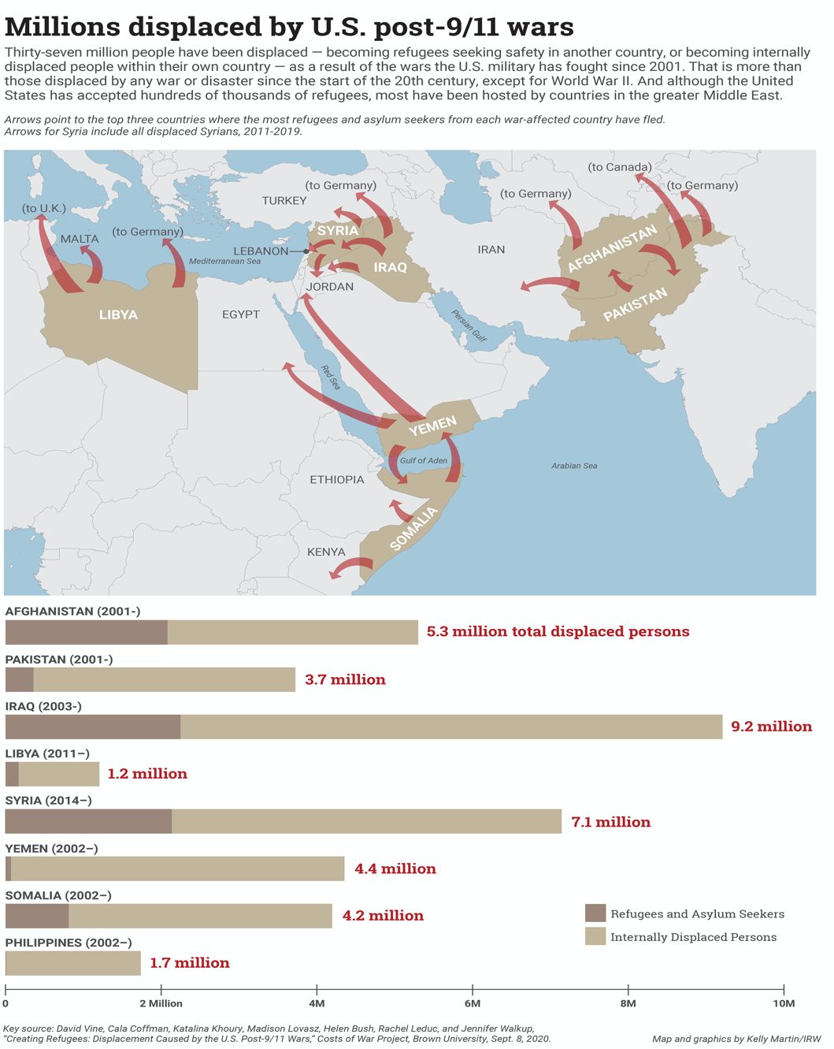

Resources

American Government and Politics in the Information Age, University of Minnesota Libraries Publishing, 2011.
Cost of War Project
Finesurrey, Samuel Cuba’s Anglo-American Colony in Times of Revolution, 1952-1961, Unpublished Dissertation (University of North Carolina, 2018).
Finesurrey, Samuel “Contesting Circuits of Empire: Afro-Caribbean Migrant Labor in Cuba, 1899-1958” (CUNY Academic Works, 2020)
Pérez, Louis A., Cuba in the American Imagination: Metaphor and the Imperial Ethos (Chapel Hill, NC: University of North Carolina Press, 2008)
Shultz, Connie “The Media Failed Us in the Lead-Up to The Iraq War” The Nation January 16, 2020.
Takaki, Ronald A Different Mirror: A History of Multiculturalism (San Francisco, CA: Back Bay Books, 2008)
Takaki, Ronald A Larger Memory: A History of Our Diversity with Voices (San Francisco, CA: Back Bay Books, 1998)
Vietnam the Downward Spiral
Vine, David, Cala Coffman, Katalina Khoury, Madison Lovasz, Helen Bush, Rachael Leduc, and Jennifer Walkup “ Creating Refugees: Displacement Caused by the United States’ Post-9/11 Wars” Cost of War, September 21, 2020

